WebFashion Project Status Report

Date—06/03/2016

**Status Summary**:

The project is about creating a website as online store for a fashion merchant. There are some charts and numbers are going to present to show you an overview about the project, helping you understand how is the project going and the direction it is heading.

Within this report you will find the following charts:

* Cash Flow
* Resource Overview
* Work Overview

**Project Schedule Overview**:

* Project Completeness: 7%
* Work Completeness: 4%
* Total Cost: $129,568.00

**Status Reports**

1. Cash Flow
   1. 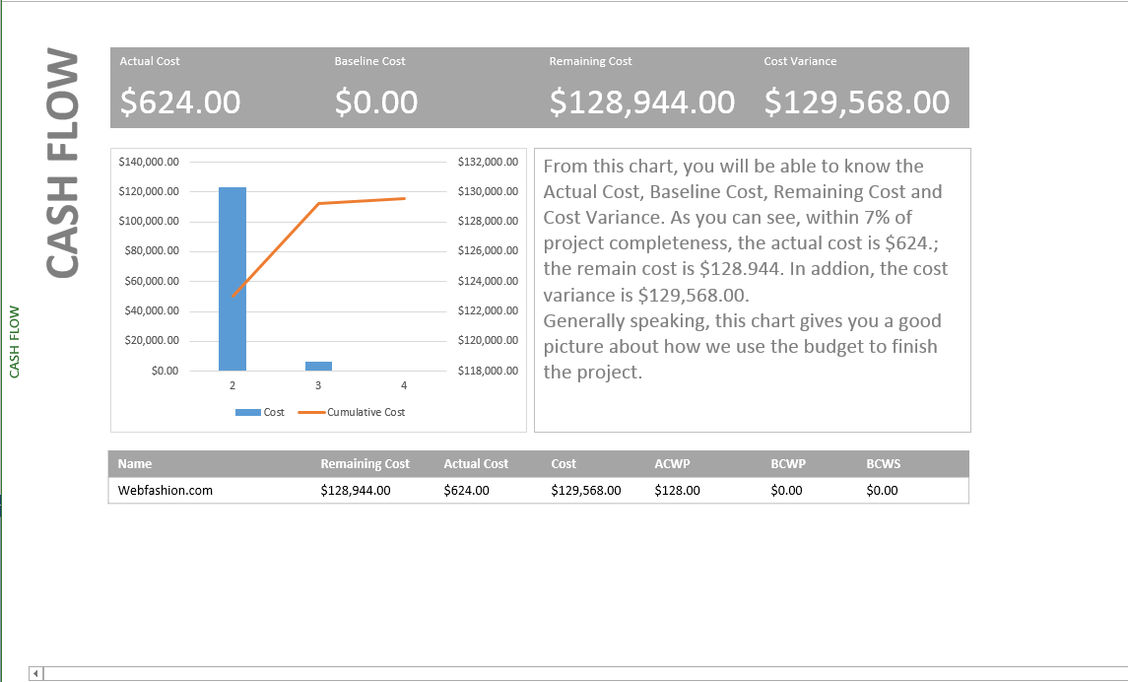
2. Resource Overview
   1. 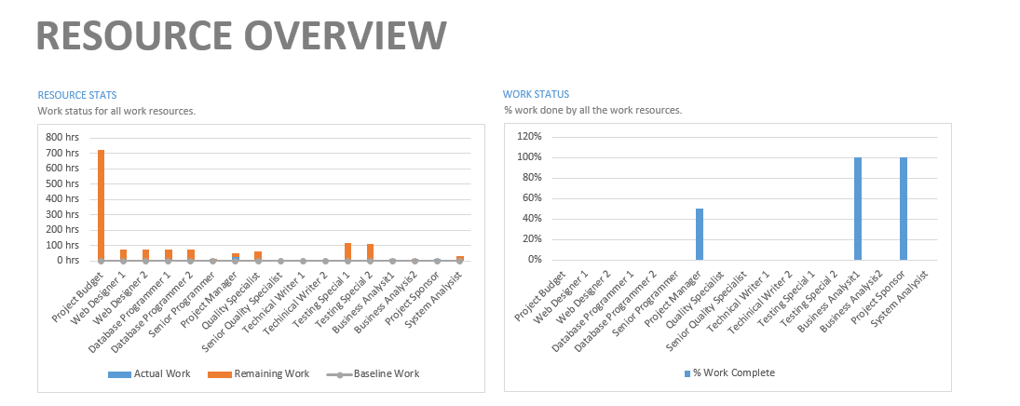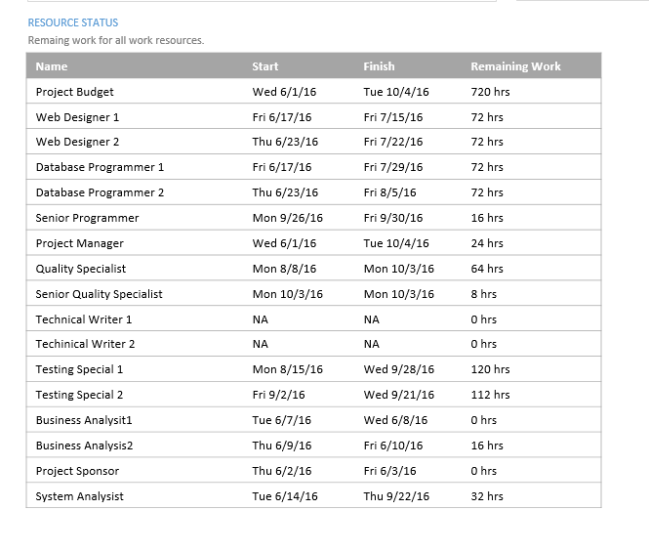
   2. The Resource Overview actually show how we distribution the resource and the usage of each resource. From the chart, we can tell business analysis and project sponsor have done their job. Project manager has done his job by 40%. Also, we can tell that web designers, database programmers and testing special have the most work to do. Especially testing specials, they need to work over 100 hours. It actually show we can do better in distributing resource. In this case, it is possible to hire another testing special.
3. Work Overview
   1. 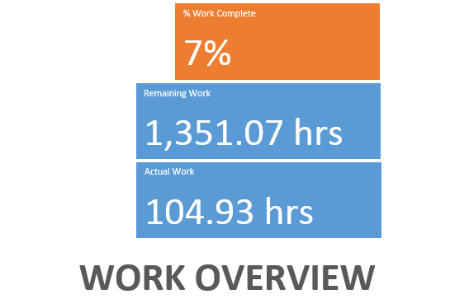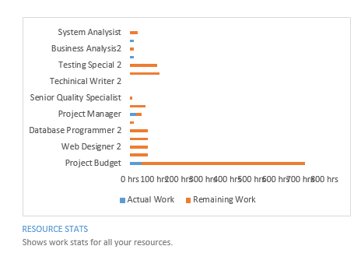
   2. As we mentioned above, the project has only complete about 7%, which exactly the same number showing in the Work Overview. Also, the Work Overview also shows there are 1351 hours remaining to finish the project. What’s more, Work Overview also shows the work situation of different resources. The blue bars show which resource has started working. The orange shows the remaining work. As the chart shows, right now there are only couple resources making contribution to the project. They are system analysis, business analysis and project manager. We expect with the development of the project, all the other resource will join the project till the bars become blue.

**Project Concerns**

Since we have two interfaces and two databases needed to build, it is highly possible the cost will be slightly more than the estimate budget, which is $120000. I hope there will not be a major issue to stop project being completed with high quality.